**Week 9 Session1- Lab**

**Question:-**

Create a Database & Table Using MySQL Command-Line Client.

● Create a database with the name StudentManagementSystem.

Create a table with named Student with attributes:

● StudentID (Primary Key)

● FirstName

● LastName

● DateOfBirth

● Gender

● Email

● Phone

Create a table with name Course with attributes:

● CourseID (Primary Key)

● CourseTitle

● Credits

Create a table with named Instructor with attributes:

● InstructorID (Primary Key)

● FirstName

● LastName

● Email

Create a table with named Enrollment with attributes:

● EnrollmentID (Primary Key)

● EnrollmentDate

● StudentID(Foreign key)

● CourseID(Foreign Key)

● InstructorID(Foreign key)

Create a table with named Score with attributes:

● ScoreID (Primary Key)

● CourseID (Foreign key)

● StudentID (Foreign Key)

● DateOfExam

● CreditObtained

Create a table with named Feedback with attributes:

● FeedbackID (Primary Key)

● StudentID (Foreign key)

● Date

● InstructorName

● Feedback

**Answers:-**

create database studentmanagementsystem;

use studentmanagementsystem;

CREATE TABLE Student (

StudentID VARCHAR(10) PRIMARY KEY,

FirstName VARCHAR(25),

LastName VARCHAR(25),

DateOfBirth DateTime,

Gender VARCHAR(25),

Email VARCHAR(30) UNIQUE,

Phone VARCHAR(25)

);

CREATE TABLE Course (

CourseID VARCHAR(10) PRIMARY KEY,

CourseTitle VARCHAR(30),

Credits INT

);

CREATE TABLE Instructor (

InstructorID VARCHAR(10) PRIMARY KEY,

Email VARCHAR(30) UNIQUE,

FirstName VARCHAR(30),

LastName VARCHAR(30)

);

CREATE TABLE Enrollment (

EnrollmentID VARCHAR(10) PRIMARY KEY,

EnrollmentDate DATE,

StudentID VARCHAR(10),

CourseID VARCHAR(10),

InstructorID VARCHAR(10),

FOREIGN KEY (StudentID) REFERENCES Student(StudentID),

FOREIGN KEY (CourseID) REFERENCES Course(CourseID),

FOREIGN KEY (InstructorID) REFERENCES Instructor(InstructorID)

);

CREATE TABLE Score(

ScoreID VARCHAR(10) PRIMARY KEY,

StudentID VARCHAR(10),

CourseID VARCHAR(10),

FOREIGN KEY (StudentID) REFERENCES Student(StudentID),

FOREIGN KEY (CourseID) REFERENCES Course(CourseID),

CreditObtained VARCHAR(10),

DateOfExam DateTime

);

CREATE TABLE Feedback(

FeedbackID INT Auto_Increment PRIMARY KEY,

StudentID VARCHAR(10),

Date DATE,

InstructorName VARCHAR(30),

Feedback VARCHAR(100),

FOREIGN KEY (StudentID) REFERENCES Student(StudentID)

);

select * from Student;



select * from Course;

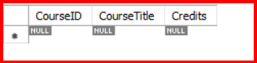

select * from Instructor;

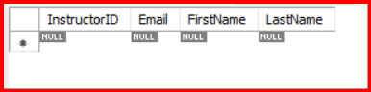

select * from Enrollment;

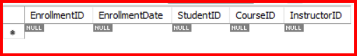

select * from Score;



select * from Feedback;

